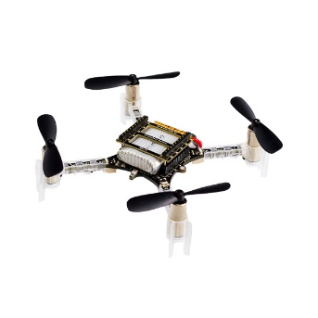

Control messages over radio

CfClient  
Interface with crazyflie

(x,y,z,yaw)

(x,y)

Navigation

Capture vicon data stream

Control  
4 PID Controllers

Guidance  
Optimized GVF

(x,y) carrot position

setpoint

Roll Rate  
Pitch Rate  
Yaw  
Thrust